**CALL FOR PAPERS**

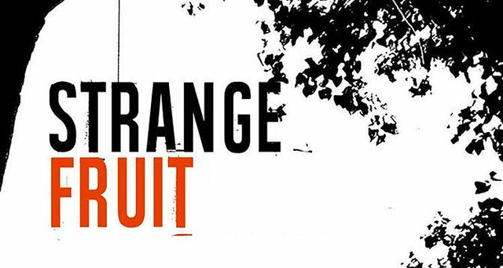

**STRANGE FRUIT: EMBODIMENT & EMANCIPATION**

**Chicago Theological Seminary|Chicago, IL |April 12-13th, 2019**

**Keynote Speaker**

Dr. C. Riley Snorton

Author of *Black on Both Sides: A Racial History of Trans Identity* (2017), the winner of the Lambda Literary Award for Transgender Nonfiction and An American Library Association Stonewall Honor Book.

**Synopsis**

While 2019 marks the National Quad Centennial, the time believed by many that Africans first arrived to the “new world,” evidence suggests that the mass transport of Africans to the Americas can be traced back to nearly 100 years before this date. “Strange Fruit: Embodiment & Emancipation” seeks to look critically at this history, to expose its assumptions and interrogate its omissions, exploring the interstices and intersections that exist as a result. The title invokes the song, “Strange Fruit, written by Abel Meeropol and sung by Billie Holliday: “*Black bodies swinging in the southern breeze. Strange fruit hanging from the poplar trees.*” This conference engages the legacy of slavery and its different iterations and their deleterious effects on black bodies throughout the history of the US by asking questions such as: How might we think of lynching and “strange fruit” contemporaneously through the lens of violence against black bodies? In what sense is black embodiment a contestation or protest of whiteness? How can emancipation from mass incarceration, voter suppression, and police brutality be conceptualized and actualized in the age of Trump?

**General Call for Papers**

Chicago Theological Seminary invites graduate students working in the humanities and social sciences, artists, organizers and intellectuals (broadly conceived) to submit papers on topics including—but not limited to—embodiment and,

* Emancipation
* Religion and Spirituality
* Gender and Sexuality
* The Invention of Whiteness
* White Supremacy
* Transatlantic and Slavery
* Transphobia
* Sacred Memory
* Sacred Text (Literature or Bible) **OR** Body as Sacred Text
* Cultural Criticism and Race Theory
* Indigenous and Black Interaction in the “New World”
* Capitalism and Economic Inequality
* African American Religious History
* Mass Incarceration/Mass Criminalization
* Black Aesthetics (arts, visuals, etc.)

**Submission Guidelines**Please submit an abstract of no more than **250 words**, a short biographical description, email address and academic institution by **January 16, 2019**. Proposals and questions should be sent to conference organizers Quincy James Rineheart and Shea Watts at [CTSgradconference@gmail.com](mailto:CTSgradconference@gmail.com).

**PLEASE CIRCULATE WIDELY.**